**NAME : Y.YAMINI REDDY**

**REGISTER NUMBER : 192211153**

**CSA0269 C-PROGRAMMING FOR PROGRAMMING ARCHITECTS**

**DAY -01 ASSIGNMENT**

**1)** Write a C program to check positive, negative or zero using simple if or if else. C program to input any number from user and check whether the given number is positive, negative or zero. Logic to check negative, positive or zero in C programming.

**Example**  
**Input**

Input number: 23

**Output**

23 is positive

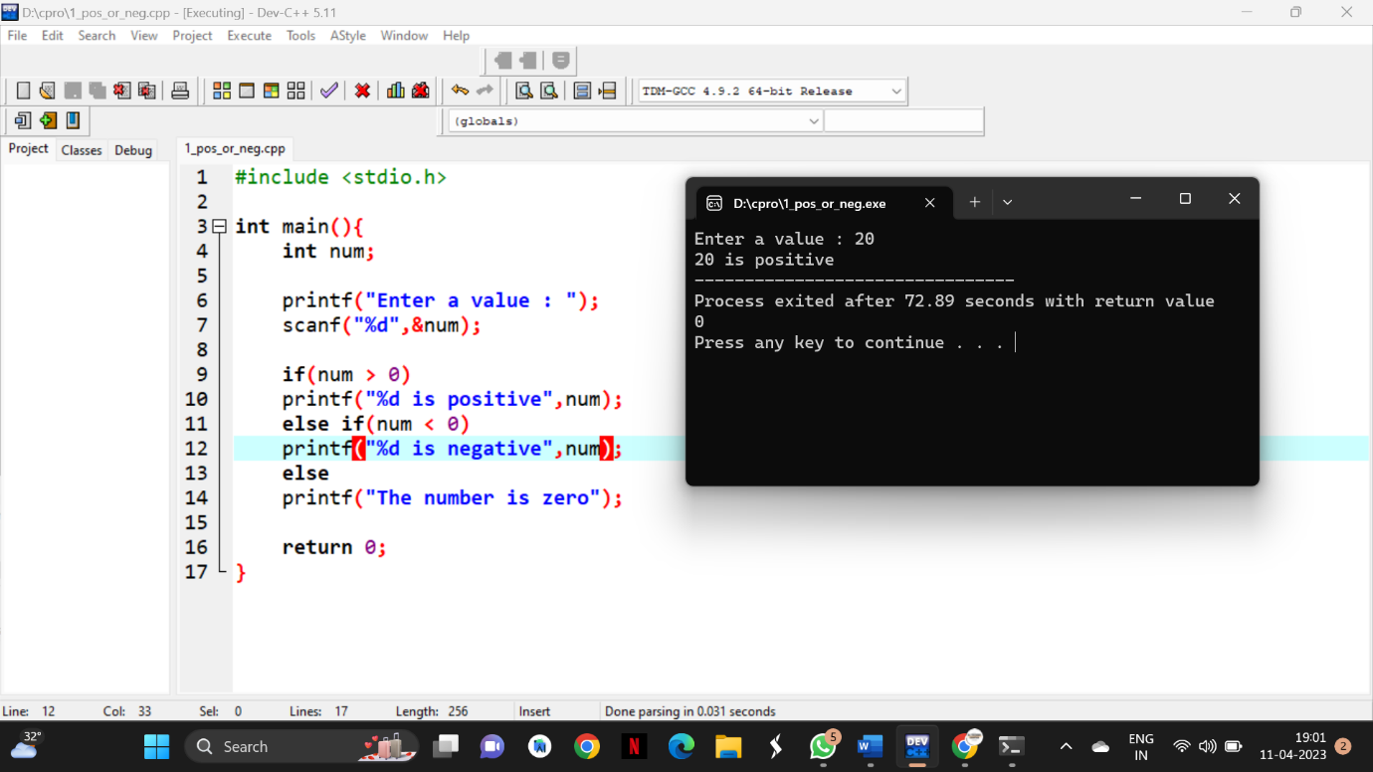

**2)** Write a C program to check whether a number is divisible by 5 and 11 or not using if else. How to check divisibility of any number in C programming. C program to enter any number and check whether it is divisible by 5 and 11 or not. Logic to check divisibility of a number in C program.

Example  
Input

Input number: 55

Output

Number is divisible by 5 and 11

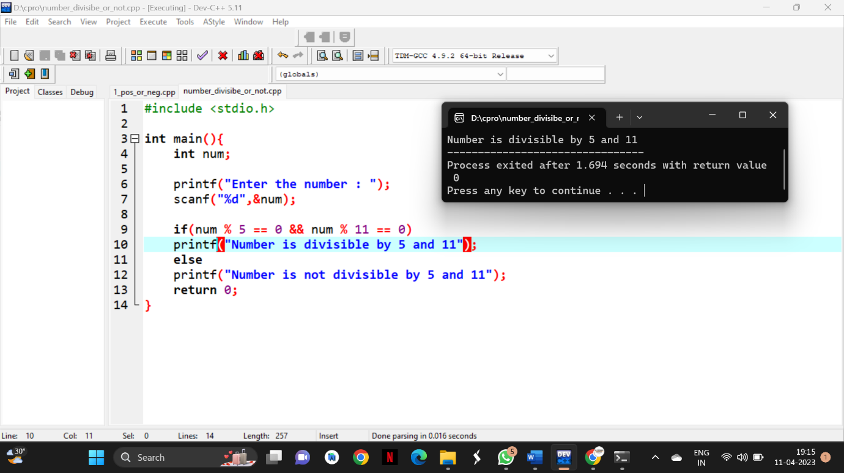

**3)** Write a C program to input a character from user and check whether the given character is alphabet or not using if else. How to check whether a character is alphabet or not in C programming. Logic to check if a character is alphabet or not in C program.

**Example**  
**Input**

Input character: a

**Output**

'a' is alphabet

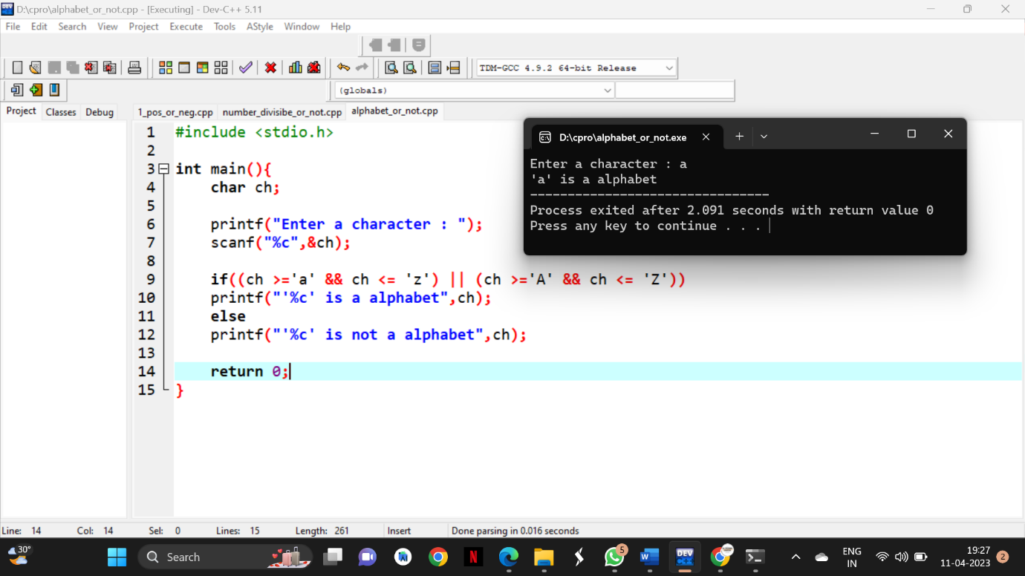

**4)** Write a C program to count the Vowels in the given string.

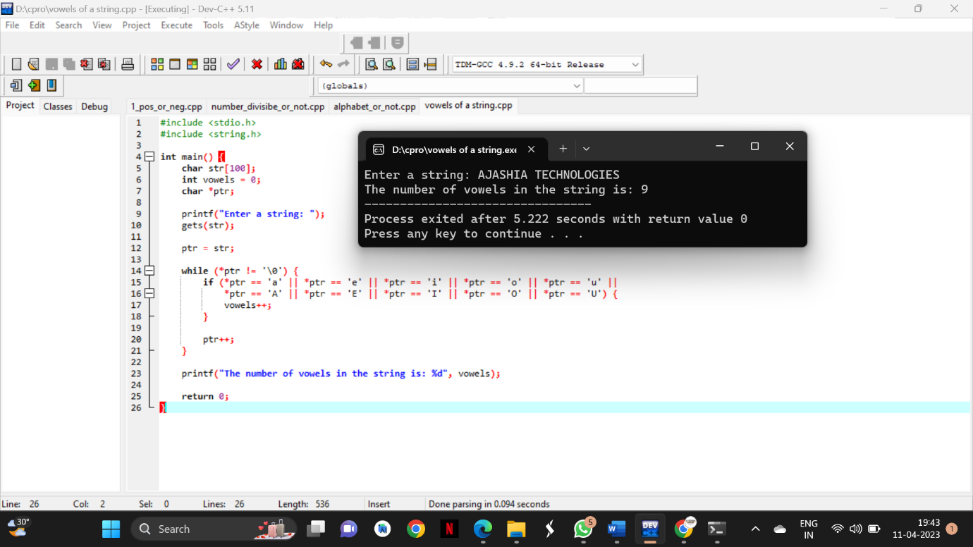

**5)** Write a C program to input character from user and check whether character is uppercase or lowercase alphabet using if else. How to check uppercase and lowercase using if else in C programming. Logic to check uppercase and lowercase alphabets in C program.

**Example**

**Input**

Input character: C

**Output**

'C' is uppercase alphabet

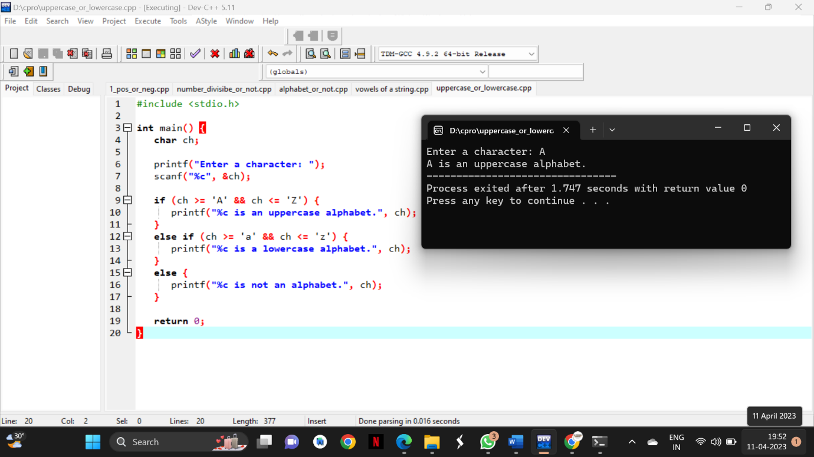

**6)** Write a C program to input amount from user and print minimum number of notes (Rs. 500, 100, 50, 20, 10, 5, 2, 1) required for the amount. How to the minimum number of notes required for the given amount in C programming. Program to find minimum number of notes required for the given denomination. Logic to find minimum number of denomination for a given amount in C program.

**Example**  
**Input**

Input amount: 575

**Output**

Total number of notes:

500: 1

100: 0

50: 1

20: 1

10: 0

5: 1

2: 0

1: 0

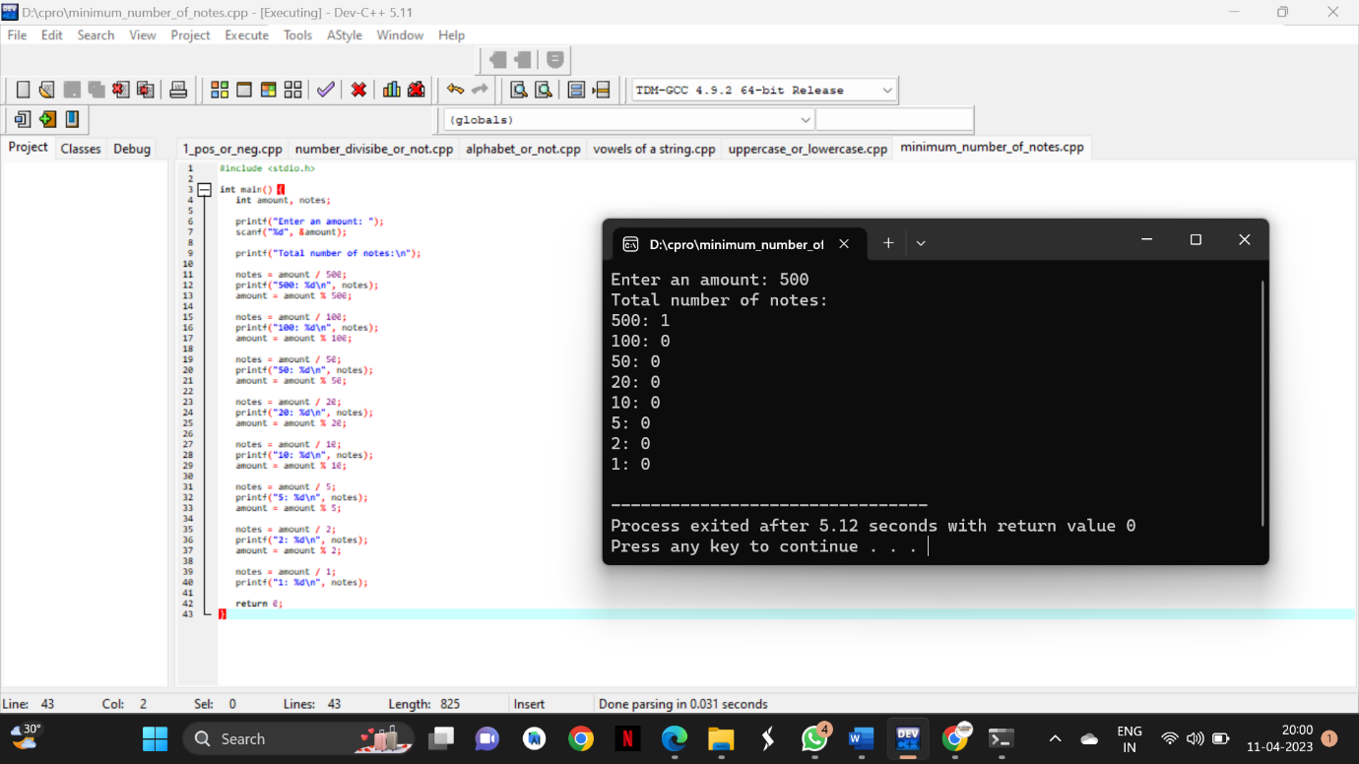

**7)** Write a C program to input a number from user and count number of digits in the given integer using loop. How to find total digits in a given integer using loop in C programming. Logic to count digits in a given integer without using loop in C program.

**Example**

**Input**

Input num: 35419

**Output**

Number of digits: 5

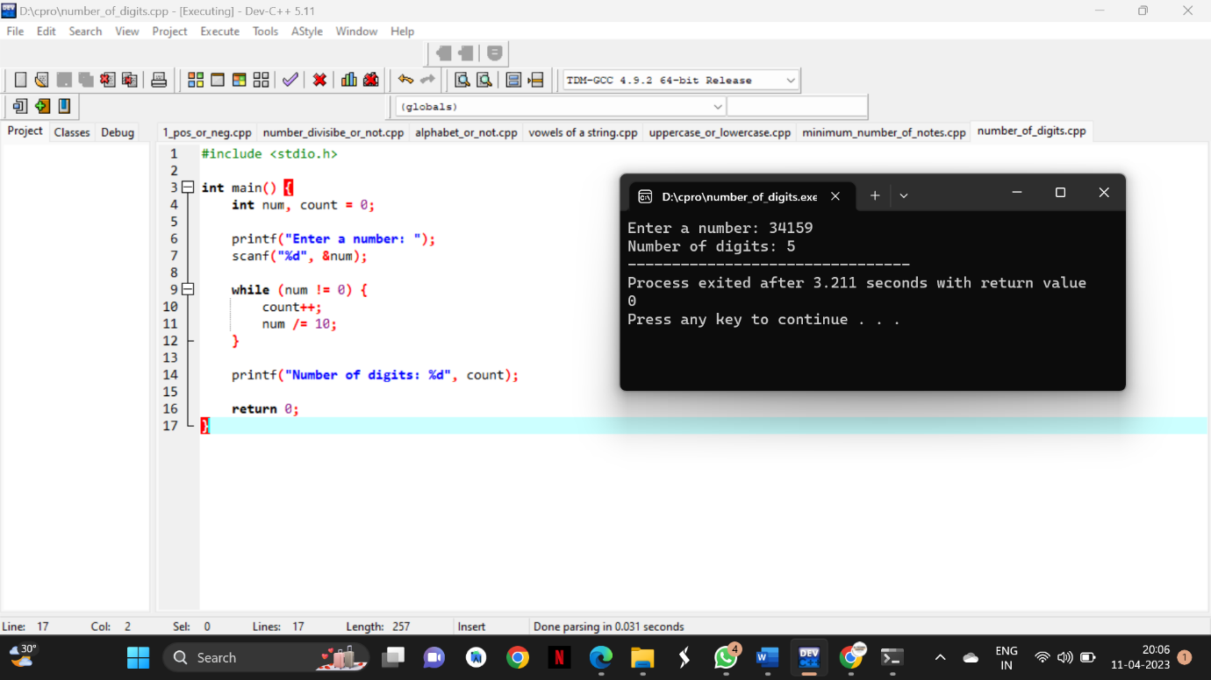

**8)** Write a C program to input a number and calculate sum of digits using for loop. How to find sum of digits of a number in C program. Logic to find sum of digits of a given number in C programming.

**Example**

**Input**

Input any number: 1234

**Output**

Sum of digits: 10

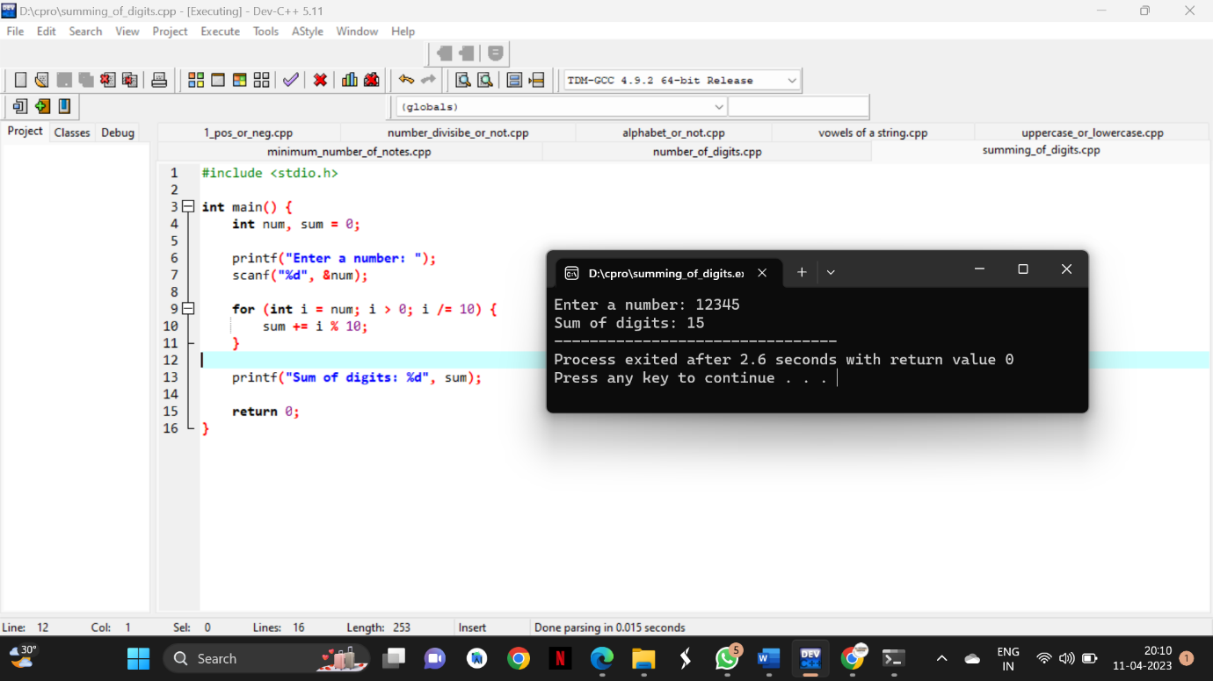

**9)** Write a C program to input a number from user and find reverse of the given number using for loop. How to find reverse of any number using loop in C program. Logic to find reverse of a number in C programming.

**Example**

**Input**

Input number: 12345

**Output**

Reverse of 12345 = 54321

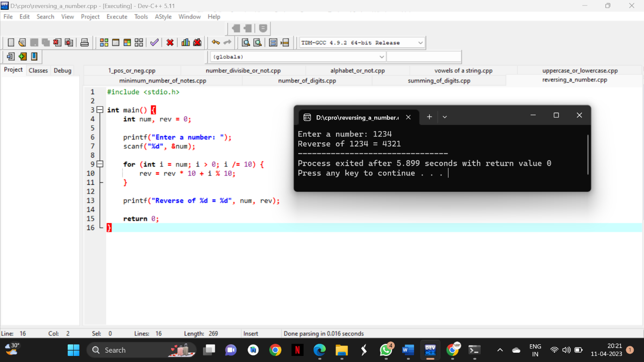

**10)** Write a C program to input decimal number from user and convert to binary number system. How to convert from decimal number to binary number system in C program. Logic to convert decimal to binary number system in C programming.

Example

Input

Input decimal number: 112

Output

Binary number: 0111000

